**Answer Sheet - SQL**

Name : Sachin Kamath

Phone No. : +91 9632231897

Email : salesconsultantblackfrog@gmail.com

**Major Question 1**

1. List the salary of all the employees.

SELECT SALARY, ENAME FROM EMPLOYEE ;

Insert Image-

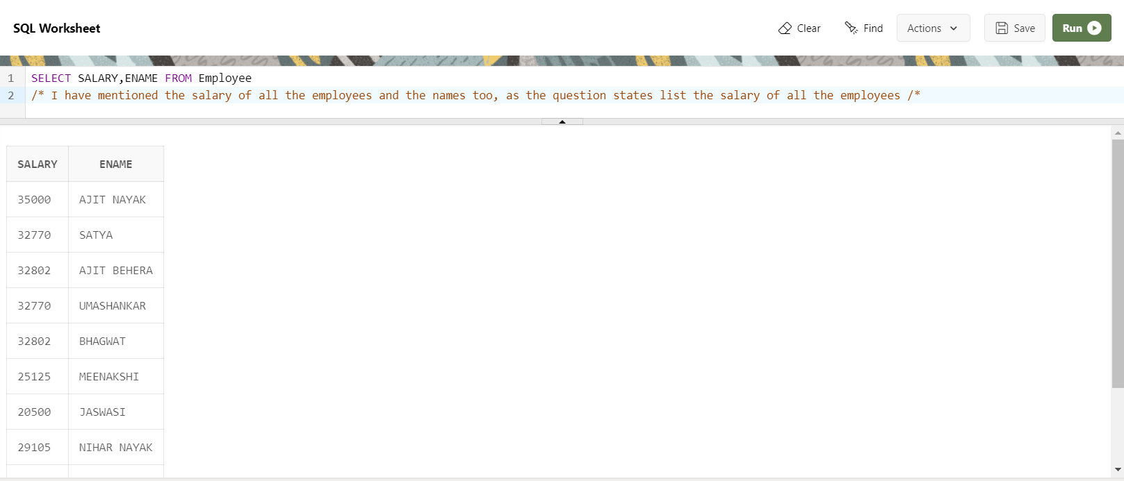

1. Display the names of all employees with any “A” at any place of the name.

SELECT ENAME FROM EMPLOYEE  
WHERE ENAME LIKE ‘%A%’;

Insert Image –

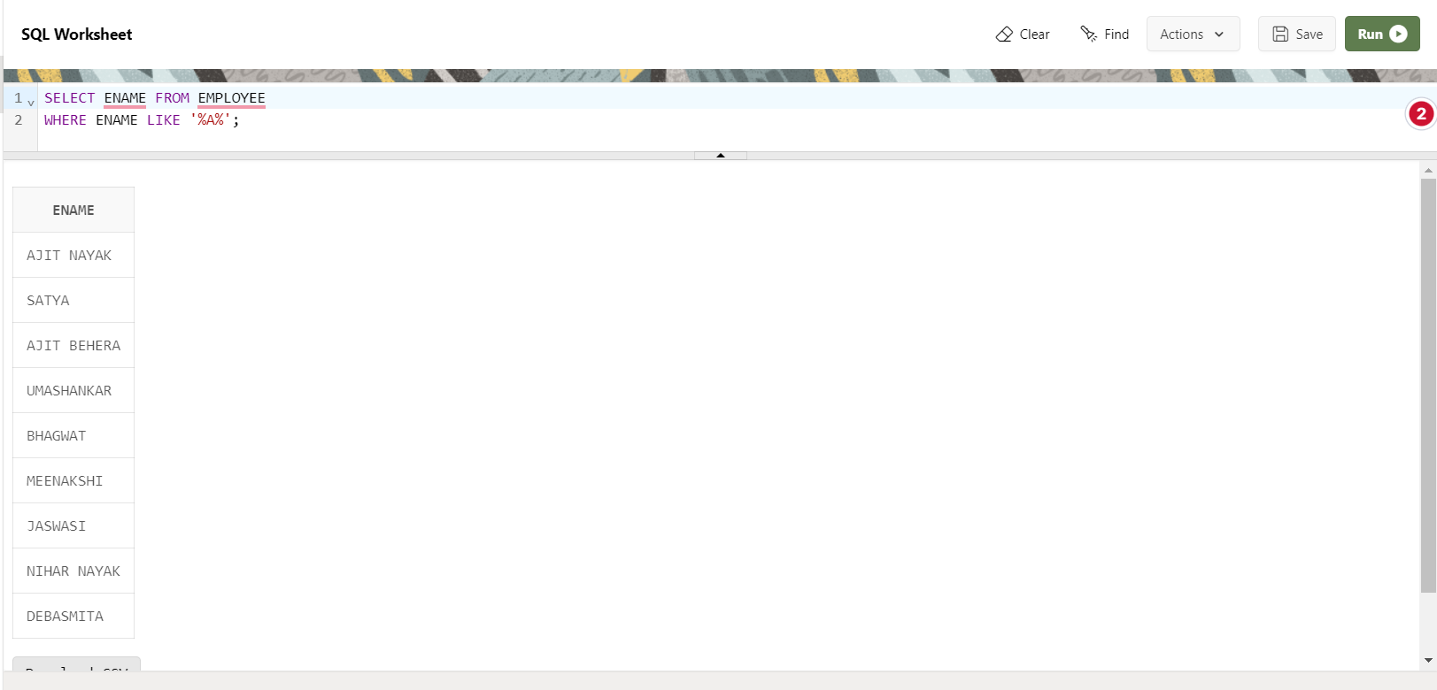

1. Show all employees who were hired in the first half of the month (Before the 16th of the month).

SELECT ENAME, MGRSTARTD FROM EMPLOYEE A INNER JOIN DEPARTMENT B ON A.MGRSRNO=B.MGRSRNO

WHERE TO_NUMBER(TO_CHAR(B.MGRSTARTD,'DD')) < 16;

Insert Image -

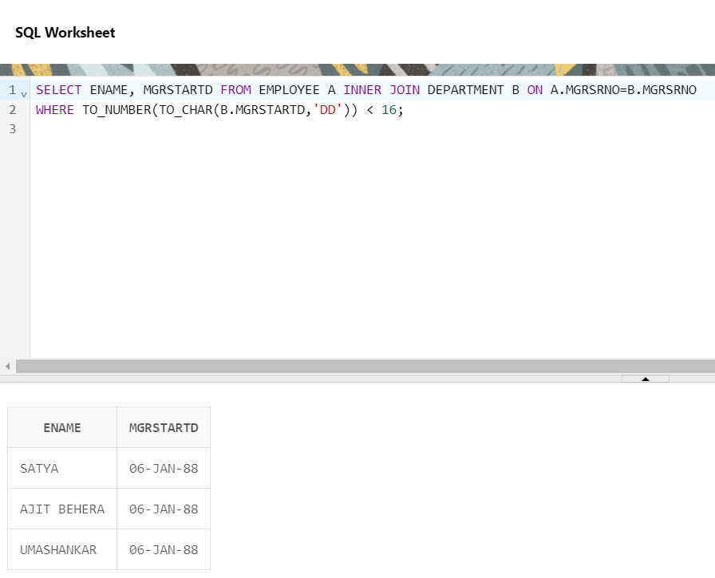

1. Display the name of all female employees.

SELECT * FROM EMPLOYEE  
WHERE SEX = ‘F’ ;

Insert Image -

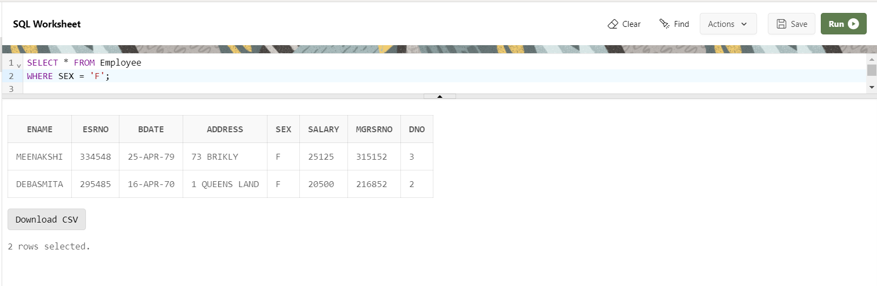

1. Display the employee who is paid most in the company.

SELECT ENAME, SALARY FROM EMPLOYEE  
WHERE SALARY = (SELECT MAX(SALARY) FROM EMPLOYEE);

Insert Image –

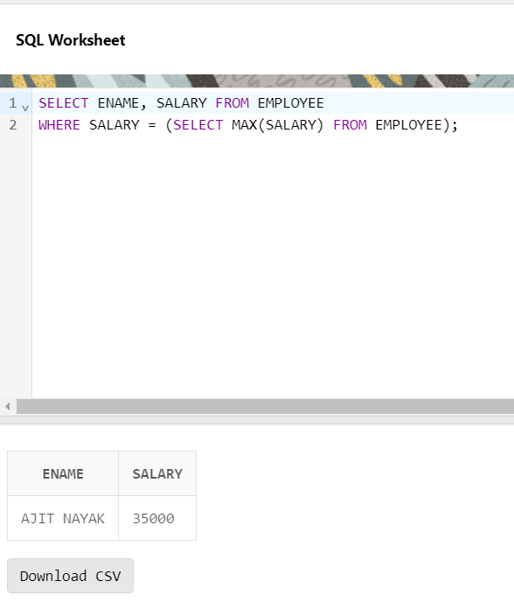

**Major Question 2**

1. Display employee name, address, department no and department name.

SELECT A.ENAME, A.ADDRESS, B.DNUMBER , B.DNAME FROM   
EMPLOYEE A INNER JOIN DEPARTMENT B ON A.MGRSRNO=B.MGRSRNO;

Insert Image –

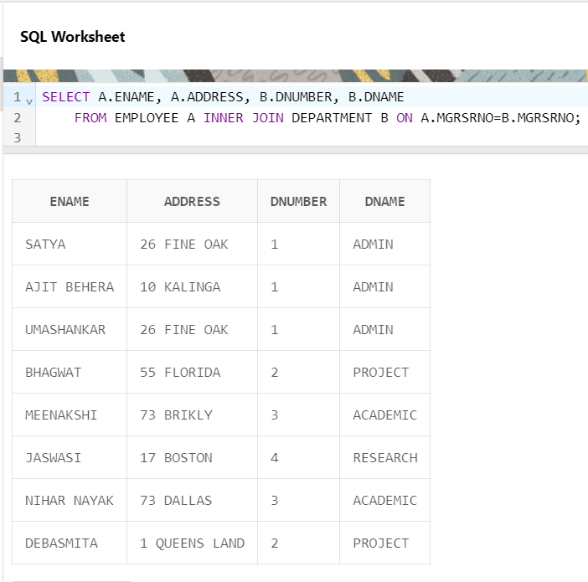

1. Display all the employees who are *not in* ACADEMIC department

SELECT A.ENAME,B.DNAME FROM EMPLOYEE A INNER JOIN DEPARTMENT B  
ON A.MGRSRNO=B.MGRSRNO

WHERE B.DNAME <> ‘ACADEMIC’ ;

Insert Image –

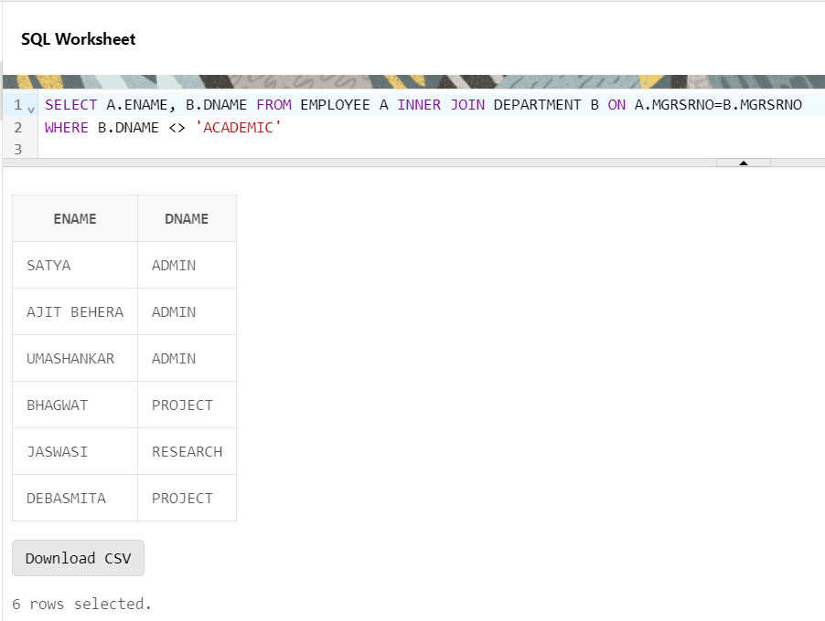

1. Display SATYAS’ project location.

SELECT ENAME , PLOCATION FROM EMPLOYEE A INNER JOIN PROJECT B ON A.DNO=B.DNUM  
WHERE ENAME = ‘SATYA’ ;

Insert Image -

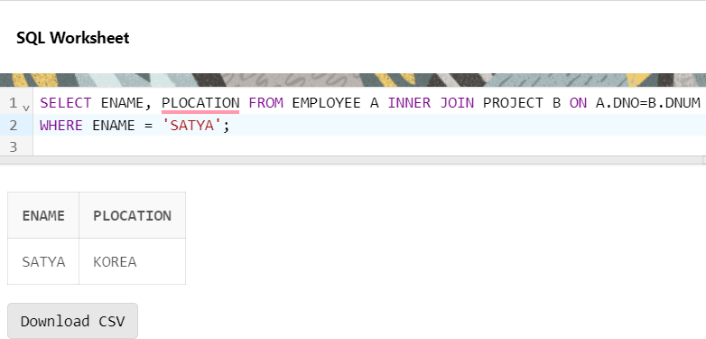

1. Find the total working hours of *each* female employee.

SELECT SUM(HOURS), ENAME FROM EMPLOYEE A INNER JOIN WORKS_ON B ON A.ESRNO=B.ESRNO  
WHERE SEX = ‘F’  
GROUP BY ENAME , SEX ;

Insert Image –

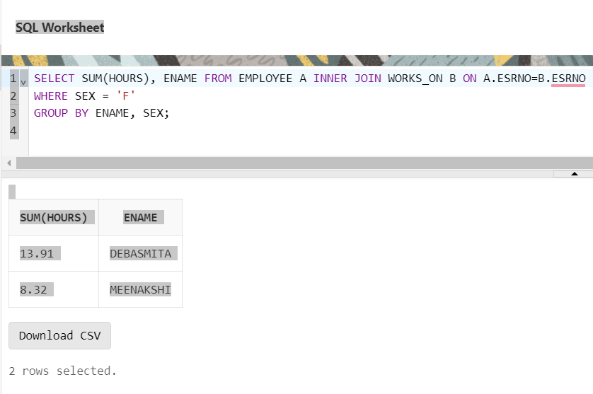

1. Display the details of the people whose projects are located at SOUTH AFRICA.

SELECT * FROM EMPLOYEE A INNER JOIN PROJECT B ON A.DNO=B.DNUM  
WHERE B.PLOCATION = ‘SOUTH AFRICA’ ;

Insert Image -

